**Topics: Descriptive Statistics and Probability**

1. Look at the data given below. Plot the data, find the outliers and find out $μ, σ, σ^{2}$

|  |  |
| --- | --- |
| **Name of company** | **Measure X** |
| Allied Signal | 24.23% |
| Bankers Trust | 25.53% |
| General Mills | 25.41% |
| ITT Industries | 24.14% |
| J.P.Morgan & Co. | 29.62% |
| Lehman Brothers | 28.25% |
| Marriott | 25.81% |
| MCI | 24.39% |
| Merrill Lynch | 40.26% |
| Microsoft | 32.95% |
| Morgan Stanley | 91.36% |
| Sun Microsystems | 25.99% |
| Travelers | 39.42% |
| US Airways | 26.71% |
| Warner-Lambert | 35.00% |

ANS:

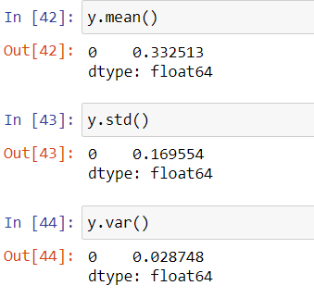

Plotting the data is given below:

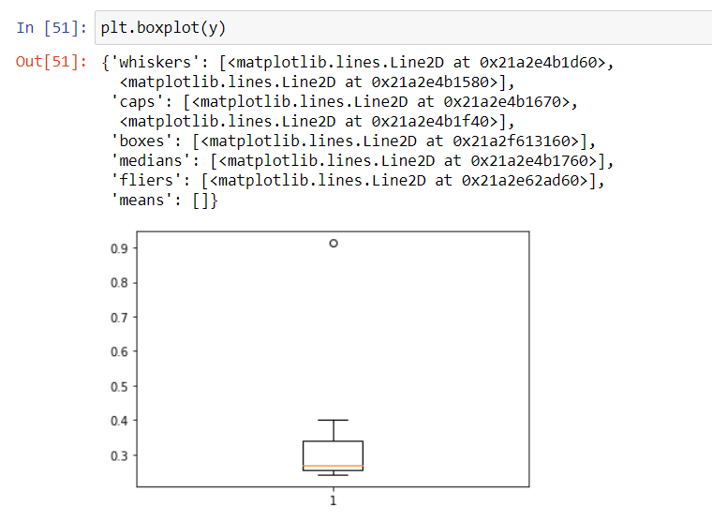

There is only one outlier that is Morgan Stanley 91.36%.

2.

Answer the following three questions based on the box-plot above.

1. What is inter-quartile range of this dataset? (please approximate the numbers) In one line, explain what this value implies.

ANS: The inter quartile range of this dataset is 7. This value implies that most of the data lies in the range of 7 only.

1. What can we say about the skewness of this dataset?

ANS: The skewness of the data is positive skewness.

1. If it was found that the data point with the value 25 is actually 2.5, how would the new box-plot be affected?

ANS: when the data point value 25 is actually 2.5 means there will be no outlier.

3.

Answer the following three questions based on the histogram above.

1. Where would the mode of this dataset lie?

ANS: The mode of the data set lies between 7 to 10.

1. Comment on the skewness of the dataset.

ANS: The skewness of the data is positive skewness.

1. Suppose that the above histogram and the box-plot in question 2 are plotted for the same dataset. Explain how these graphs complement each other in providing information about any dataset.

ANS: In the boxplot IQR value is 7 and in the histogram plot the mode of the data set is lies between 7 to 10, and in the boxplot having outlier and in histogram plot outlier is there and that i Range of 25 in x axis. The boxplot is positive skewness and in histogram plot is positive Skewness.in the boxplot 25% of the data lies between 5 to 7 and more data lies between 7 to 12.we cannot differentiate mode in box plot but in histogram we can do that.

4. AT&T was running commercials in 1990 aimed at luring back customers who had switched to one of the other long-distance phone service providers. One such commercial shows a businessman trying to reach Phoenix and mistakenly getting Fiji, where a half-naked native on a beach responds incomprehensibly in Polynesian. When asked about this advertisement, AT&T admitted that the portrayed incident did not actually take place but added that this was an enactment of something that “could happen.” Suppose that one in 200 long-distance telephone calls is misdirected. What is the probability that at least one in five attempted telephone calls reaches the wrong number? (Assume independence of attempts.)

ANS: Probability of one misdirected call among 200

P (wc) = 1/200 = 0.005

Probability of not wrong call: 1-p (wc) = 1-1/200= 0.995

Probability of at least one out of five is a wrong number

= 1-probability that all five calls are not wrong numbers

= 1-(1-p (wc)) ^5

=1-(1-0.005) ^5

=1-0.975

=round (0.02475)

=2.5% chance.

1. Returns on a certain business venture, to the nearest $1,000, are known to follow the following probability distribution

|  |  |
| --- | --- |
| x | P(x) |
| -2,000 | 0.1 |
| -1,000 | 0.1 |
| 0 | 0.2 |
| 1000 | 0.2 |
| 2000 | 0.3 |
| 3000 | 0.1 |

1. What is the most likely monetary outcome of the business venture?

ANS: 2000 HAS 30%

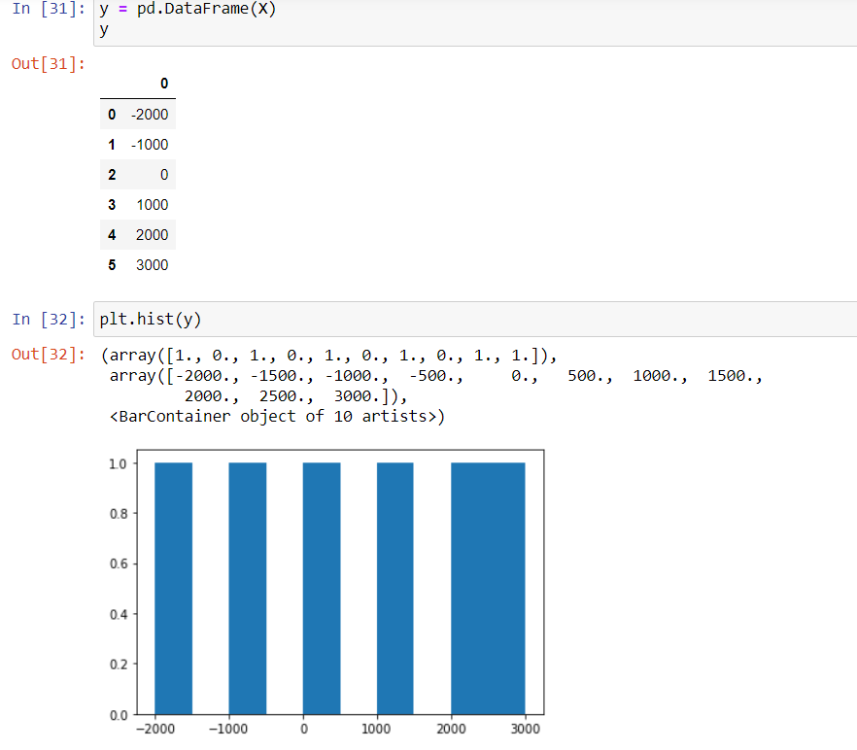

1. Is the venture likely to be successful? Explain

ANS: THE VENTUER MAY BE SUSEESFUL CAN BE SAID BY PLOTTING HISTROGRAM PLOT THE HIST IS POSITIVELY SKEWED.

1. What is the long-term average earning of business ventures of this kind? Explain

ANS : AVERAGE = 60%

1. What is the good measure of the risk involved in a venture of this kind? Compute this measure

ANS: THE VENTUER IS RISKY SINCE THE STD DEV IS HIGH.

STD VAR = 1870.829

VARIENCE = 3500000.

